tdt*d {r b €
ffi
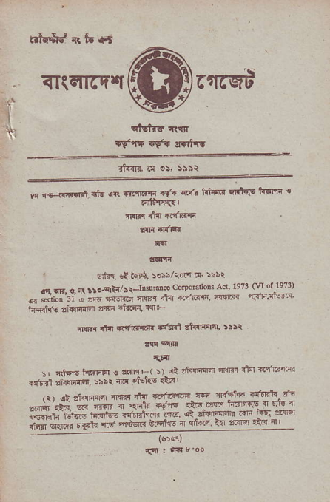
^{qIiETtrFT[} rfrrst
^{i'}I
\':
rt'rr rv? {afr!
_{,. s--.<,r-.n} it {( .tffi rl". .!ft ,'{-'{:{ -ttF trfrri ' dfdlffiSl
iltr.( .lfl !.'ftn
!'lFr il{ltl
' 1:td !! tEq, so!;/ro.t t' >:!r
_{d fr .. R !!..qtr} ^{/)} _{r-rD$'do} corpmnolr /'d lc71(u ol l9?3) ," _{"-*;i} ri : ie r"* dn _{a-i.'r} rn'6r 6c.t'!sa iffift siffiil aqsn _{flri6{,} q+
{rnt rl1l {'ffitri. +qffi ttfiiq't, 5!)i
f.f,|
_{\.:drshdrjt$€!mF(i)} ^{'',r{{-@} _{r@} 'ta1.'F _{+r6i alnirqm,} :s:r rd fts {ar I
, 11 dt thlFr]n _{filF} .'t{ _{€.r'i61F. @} 'r'.tt6 ':'*'" ai: *;' ,# ; _{;"-;} '{"'" 6!+! ,ns-.tr h'nr.I { '.ie r ii#r"-'t"'.i ^{t*"s...*t'"-} _{e6} {b"eft!5nr ^{r-i} :!I;-a@ _{i#-#i?'i-'."} -a*" t'+rs { ddc ^{ts'} ",!'" rar a
: .l|l _{! in} t'oo
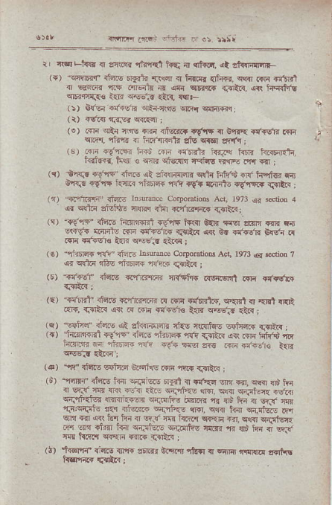
^{{Nffq.4r} _{"'ir} ⁻ a: rr|i
r, ffi ^{rh!?} { aqt.& itdal tq { (ihor. {t !ft{illnlF ({) "ennbilr _{rid.E Farir{} ^{|B1ni} r h!i$r _{{hrr,} ^{qqlr} r{Ir {effi r €lirq ^{qrF} .{.€ { ^{q qcr qEr{} _{{3&{.} ^{qri hqqtf. qlF.rnF€} _{<ri} ^{q4re-_,r} €i_{, {rr l>) _{&rei .:ridE} qEi-lrrE ^{q&q} wrijRq:
(t) i6r<l rrFFr ^{q<F4} |
(o) _{.r]a} ^{qi:{} cqs {ln {lqi.+ a{.tt T Fn r {ra.s'ln ffi cm, riraE { i;rir"aRit{ _{!tu} ^{q.6r} arfq j
.. _{3l} .vTe ^{:6d} @ _{+4ffn} ^{'.i.zr} _{hF} ,<3Fz'r Rl'F{'Eq.tm5.qq''qng
_{(r)} ^{-Er:r.r} _{+Vna' {iflE} ^{qt} sii{ r.tr _{cdr hi{'d} ^{q{' Msr Fr]} or!|- r\f{ Rn(1 lir.Td+ i{r r€. r6.rtr ^{q,rR{} \qrh.1j ^{({)} _{".Pfnr:F rt@} rirlratrcc corporalioos ac1 19?3 q 3dim 4 4r cd.i sEH. flRq Cft {.,i.iqr{ drrl1q:
(c) "+{rlr" riars l{Rrmil $VqT tffir 0'{r *rq !!nlr r@ F !!<f{ ^{:irl{lr rffi} _{"tuz:r rr1lt{} ^{q<l} B. dr61r bnf{ d
.{F {!'$sr! _{a{r.} ^{qEE'-} d?i:
(r) "nti!@ {i? ituro lnsum.e CorpoErio6 Acr, 1973 ({ sd{D 7 qi ^{qdr} _{ils} ^{?|i_{Fi6{} n{iri {.illa :
₍₅₎ ^{'{liEr"} riaio {pnr{!di {{i{rlT irstsFn .{lq {I.{fl..
_{le)} ^{'sr'trf} ihs {."rir{:mr d .{1r T{trd.+, c'{6t { EEi .mn .r@, _{<{rr.} i+ @ @.i f4i6€ l5r @83 {:.{,
_{(E)} ^{.tqlla} rlftE ,41 ei{Trrr4n ^{cks rnllt€E E+tEv {{tr;} l{) f{rrriil {!,1? ridF rJrsF{ n{r _{{slAl} ^{qrt.rl{} tifrid rn ^{h.inn F fara+} _{"dr} if{ ffi zrs iin €tk a{n
⁽⁴⁾ "rE. r1.'rs sFlc{?l d.lqfrc _{r{n} ^{qqi{} {.llR I
^{(d)} "'rEnr" ih.g i{ir sr3i$r! flral { {t'eq w _{{r1.} ^{q@} !r"5 hr 4 s.3' ra Fq ft'4 _{ri} ^{, f{?tr<} f+ ffi ^{sFl} _{R} dEr< ^{qi'rai.{} {@:i*fl ^{6i.rF6} t!{]F{ 1r {)6 &-r 4 EF m r.'.qEt, _{t} ^{q} _{{'u4L} ^{-+.'r-.} _{m.} ^{,*r} i{a s.',d! ^{ci} sE 14 !{hi-l"i4qv E! r4rl REr4 ^{rr.} cr,sr F{d@ F w da _{fc} eJiw rirfus ^{r&B n} @ hi { Fi!, 4r! _{trrr{} ^{qr{rr} +m c{aa ,
^{(;)} ffi {'nts rrF mr E rer rhq .r E{rir aflllr r{rhE
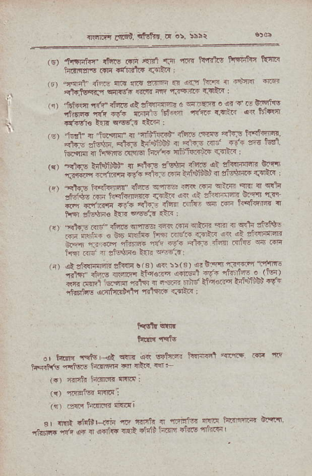
⁽⁶⁾ +rtriff fftq r{n al41 f.' rrr. i+{'rts fi*linn Rslt! ^{h.rFrsls rfir} _{"ffitlt{} Tgtt-. i
{r) "qqdt f:.. nlrrl flr{ 5rF{ {r d{n t{s n t!n46 {rsr _{rin$tqfi} q66F tr{rqt an fiqqrt' a$t" I
r) tEts r'6" {drE dt tidrtara G _{ffi o} 'r d c !iF:$ ;+; ;d{ {A ;ld- _{dr} .ir4" '!:r {d lB'F _{fl6re !:a} ^{qo_s} rlta ;
t.
,!r t-d" T f5rEr ? t/n@ +6E r.r ^{a:?:r'dlan} ' "{ d"$; R^rp * dl'c" a <"F ..- 'i'4 eiz t!r,
r.'*m a tarnN rnjq fftf'r{ riiL'f''l*Bl? T..Ft" :
k, +.1tu _{ffiiiiBl {} ^{.tds} a!ar4 r% o; siriEn --rE i3-@ _{flliqrr!.6} '- , d? i-iit'd,s- eSii+ d.r_a. _{'r,} ^{-sifl,} _{r4q1@rE{ .!erE a'r-e} iF _{r} ElF- er- a 6! rH$e _{3F} ^{'b.d-F'F} _{ryi"} @ ri d'ffi- cr-q rJ' {r d'r{'lq rr'. _{F*a} ⁻ aifr _{Fn} r _{Fn} ^{Eaqt<'B} q _{nr€r sftF€ t5r} l@:d rnR ;
.{, +f.! r' .er,5 !rc @ r '}'n n a *t 1& ld m.dR € cF fintr{ h_ _{6s'R r.+i_' d'} j'3i-rntm
hfl Rr' ' _{!HF! itE} r'"*-Fl
-) ^{.l} riqrii4 zt{llr 6 s, oa is(s' _{!.0--'Ji@} 'kt _{..r*r 0t",. +m t^'"o?t .Eq!t} 6q- 3...i- . rt-_r _{!w d.Ft} qrq{rfE4.{@srt€,.a'@';5# i? _{ntl'iir€} 6nMdi nrlFt{ {FrtF:
_{irclr} qltr
h i rttu
e, hLM _{tFr+} ^{q{B qR} w'lrFi h!r{I!nl ePri$ ffi r'r _{rFll(b rrtuts i{ffiF} ^{q} {Err' w F
(.) {ffi?r li.dn'f{ 4$.{ ;
(r) rFnt n4dl
_{ir)} rFi{ h.irllf {i{Ei
sr _{Gt} triL{F _{nre ti,\ {} Fl_F 'l-r: _{l;rr-E} :!Yn _{nhnrr{} q{' ^{q} { ocric {rF +tri l"rrF 'r{|E lnard
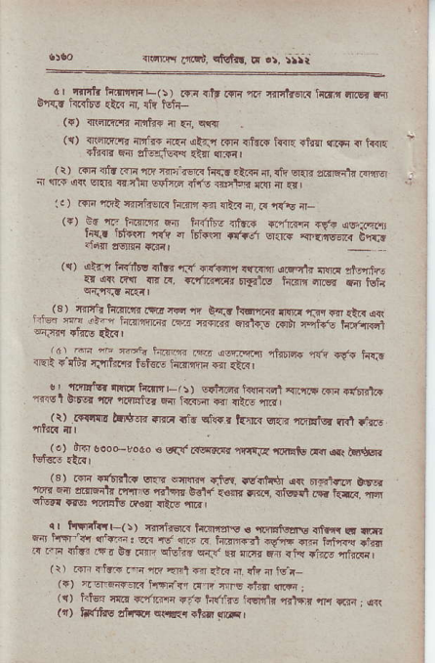
^{c} _{-irErr} ^{hrDnqL(ir} ifiit _{.-i,..} ^{'?F} 16.r'4rr ^{rE !.{} 6'rri' R!!iw {arc r {r lst{ ^{(r)} rRa'!rm{ irlttri ir €4, cqq
(() f"r.e'n it_r. .F rt-- m {ivF.r!R ^{.Aa} {rF ! ^{t{arr} rrf@ *ir strjq{{ _{{l{T} ^{qFi} I ^{(i) Flr} _{"fr} FE {q f{n ffi i{f.. _{rtri {.} ^{qli} var. aRFfir ^{lrrw} _{i} q.r ^{q.l} sEn r'ntr lsia {ir.6 i.jd:q {.$ ir !F l.) rn? rdR f,*rrT€Ta t{irll fil !1!n n, ({ ^{'fris} a_
⁽⁺⁾ _{.G.} ^{r.-.rtr!r@ F} _{FE} r?. nr1-ft ^{olb i"...r} ).-{,! si?tz ta, . F_q .a,.,_ 6.F ^{rt,IF.{} aar'
(q) ^{qtrq} h{ r! {tr rF r{.rnq {tFin' {Frt r{.{ ,ffic .r o,n Rlr !R d, .df.rrrrr 'Igts hinn 4.€? fa M_
,. (s' ^{'r-r4r fnrr.qr&} ? bdi!.!erri@.Ftr @ F4 {r"r !d _{I} ^{-l -.' 5r"Frn1} _{.!e} ^{'rE} a ^{6Ftq!} _{@n} ^{F-Fs} ?.".'.qt .:.-- * _{"--.q r.'ll-} ^{.5} _{r'r'llfi} ^{rd,r} w.!-. ^{hf.n} {Fri tdlrr r.'iiirr, HoE Fr{FnE d .rar _{c.} 'r-tEtsr ^{q.zr} Frirr E/r, sdrran ?cFn l slrlcE r ^{,t'6-4!ir} rcl _{srF t r.r} ^{qnEier} _{Fn} ^{j.r{F{} s rrro m l , ]t) r.'Fl:I! F.rlrB -ra _{fd} ^{q".w,} _{tt"nr r'r.} ^{.r-rEt!E} rlli fiis
_{M#)*l} 06orrod6 € ^{qt'} r.\,F,.q _{4ltrs} ^{,mFls} drd a.l ffiir ^{(Et} rni Frtrrtfl ^{g_} 5;1@ .rsr. .dr4'i+ rc _{rf.',.,} qre ^{.r} Ei !rrpi'-m s {r.a c!]}- _{. €a -,i.} qiw.+ _{dNr{} qrq _{q.qri!} r.r k ui@ _{ft4} ^{qt$} ,rR?, ^{q ' trFriiGt-(:)} ryri@ iaqlr! . iir,.wFd vtk r, {..fi _{f} ^{.-} f'!- ^{-i} iir _{rE-,} !.sn. sF E r{'r F _{ft} q.dr, ,niflTil ^{(t)} m dft _{m} ^{,iiq si d} tR {. di { ts.r-
^{(r) '.-lGareIl} i,M{n _{r.rv fls il.!l} qffi:
^{(q)} hlEr nlrr r.,rri...F ]-lv hffrc k€l'nr rr,l,ni m _{rrin:} q( ^{(t)} _{&glts stuq!} ^{qsrr{r} _{dnr} ^{qlF} I
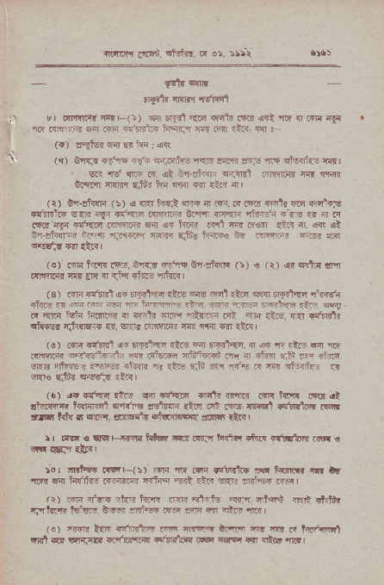
Ts{rr< d.qd, ff{q F 05, :>ri
' _{s!t{} qlrft
t{rrt !'{n Ftr.il
_{r r 4nirr{a} ^{'rd{E(:)} sl _{'lin} '{ie ^{qrlr} ffir <{i fi n iqi rF _{re m'rnj} ^{qn-'} r{n ri!6]n1,|{ hq{z nrr .q?I tr<, ff '
^{({)} zqbr d{t E{ lrn ; a<r
i.
({) onr?r {dE iq.qii{,h- {e]j ltm arF n t' ^{qi6{f.E} ffi3 _{s.} ^{'1d} cF rz rt _{!,j} ^{-t!i} {r{{i
orqit m{nr dnr fti {q:r f{ .Ll nl
(r) G'r-alr(ln (!) { rll hEF lnir n lr{n .{.4i. rr.}j @ n'l'rp _{+ffirs} ^{q{F} iVn c'?6 .rr,lr@ S.ttr {.'rF rffiE €?s .r ir rt .{in'ig{.t'aiq rqnrr€ _{w} ^{q{} li.R R.1@ tur {tr {. q< (t Sn'"li{r:r iF;$ {rrEpr {qri elis ftt* bq
^{(o)} Fn lirr..ft!, _{6rfr {s1'n!} ^{gr.lrw} (:) € (r) ,cr aRtx !r'f Ff,rd a s'r º _{{q} ^{.4d.,} "n-m,
(3) m ids?]a. rsft.<.{irs .m rr'l,t.no ^{IR} ryd'{q rwr ifrGa.a.*drtu'@ftta o.1?.l-3F ffirF.i- iK. _{F} ^{'?nq} 16lq iir|IFr{ o _{4?ik} ^{gnF} _{{t{F FE} ^{'.ri} .irc, {{r iff" {nrsr rj<nF{r {{. wr. c'riflrFr crr drdr T1T {tr I
{6) _{.{ri} ^{,il!1 q6} _{6l}rt {?l das} ^{q} r€1?ar. <r @ n .he rar iii _{.nnrq} ^{qff€,rti} 4 aJgF al,'5aFb nq a afa{ aJi nn. +lrFr wF ^{'fe-"} rc-d +h{r rr .is Eib {{r i!,E F ri rn'.,l.j <r e(Is Fllir *sEJ rii{ |
(.) {{.{"qr {6F rr4 rfta {rrt{ irlm nn ldq! i!6 {l _{rl!.rEn tur@n} ^{q'r{B} zdtffi Etq a! i*?r. |r..q1 lnfficr ffi _{rr- ?rlq r} qFr. grBF{'td ^{6k{prq} la]n {lR ,
r r Fq. llqFq{e Li* xr df5 ti{ff. +nrd +ffiqr |rq !
ro r rFl*T r|Gr(>) m n .r" rrtrlL! N t+am l{" ir *'' rit hrrfre iT.ig!4* r<ftq Gt _{.id} ^{qqn} driq i@r /r) rr]n T?-r dn{r i{i!l< _{.'e alftr} ^{'rfl} T.iq$ nr€ +}t! iJhrrr id@. &e cFic .q ffi 6 {&! 'ltRl
(o) iffi t{F +'d6rrtq tq &ttq trlF d E .r krdil _{!B1a} ^{qqiB} lrr{i?hF.,t'rFll rFr r{d"r *l lrtdv.iFl
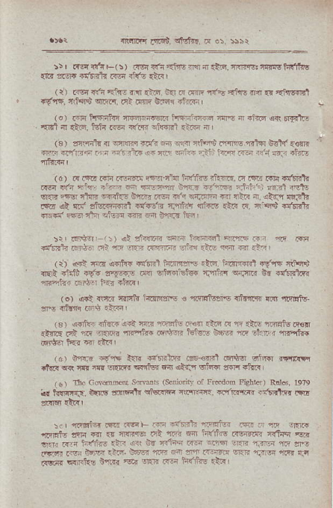
^{{rfid"} _{L!'i€i.} ^{qtrl.f.} tr e:. 5s\r
!:r .rs{!!lF(!) .!s{fi i{!rErtrn€li'5.ir6w?r|!sfn{ll4s {i,? s.'5iF crtitr r{6 d!'6 rar I
( l) nsi sn tnri dlr aiF e{l _{i! dflrF} ^{'f{"s qnrs} ir.{ {t {r'nfi{t _{16!lf.} qt?qld ^{qGrr.} .|1 .Iw tr ft +in3r I
(o) .6lrl trFFtin fi,rffi tsr4rnfil@ ;]N ª _{"r?rq} ^{qrr} Er+rrE
. {El ft at E. tfi .iq c'rq eknl rlid { |
a3) fl{nr _{n} ^{qnffi} _{t {. d} ^{qanr} _{r,!qd lefrc r.ld} gd.'€!?F {Ft *'iri,ri .r:r. ^{nlt} _{rar+} ^{(r} ri|' stsn RYI l?'n rq idn Ff, it{:t
⁽⁶⁾ .{1616.{rn..Enrr(!{Er-'fi{hi","ft rtu4t{..al?,rr{F{Effi" _{.r€i .an} ^{qir.i} +'@ n rn6Et'r oq{t i,J.'Fi rnni; ^{srl Nft} q{]n F4d ll4r _{rrnft-} ^{q,rFr} R6{ d{ w4iriFn a nftr {f. 4lTr {3.?}. _{d{6} ^{qi} ni' slffi .ffr 'flifrt ^{qt{i,5} .ttr F 4rct$ +!tdr {r€' i@ rinr .fE.r 44r .iar b,.,Inn Ed I
:r! dreq, t-\r ^{qt} .tuntri f4n4 hfirc1<r.fi
rififE sid ri _{n} ^{qri} .{{irr d,h .16. rfl 6 +i I ( li <r!t rnF oFfc. @ffi iiirl#rc .i,a turimi t!"r{ r!lq'"' _{ll€A} ^{qlr'tF} _{.t'{ !'qvdc iw} ^{qftr€Els{} _{{n'l;II} ^{q{nnr} br +ff.l.i mr.t{+ Fltq ?.i ii.Rl
(e) ^{qri} lcfa rrrltd fts]rfsrs € ftq]!tusre {itnnre?i 4.r ^{rfi!tu} n drnr .66 .tra , (s) ^{({rtuj} 4l@ _{o€ {e3} ^{'ri-rEfs} Pit r!i? F 1F.lF nmrtu |s.i {tntr d _{n} ^{q{lrr} rTPrtur d4qr t-lviq 06c n|q rt.Iar1nqtrr
(4r 0"r€ di$ l{l. rrrq.im @€rn F.'tq irf@ rFrlF _{.ka} ^{qR} cd ffi _{sl{r€ s!ft_i f,{ {if.r} ^{qlird} !6 +to! (!) Ga Gddsd sdoli (s.nionty or Fredom Fl!!te1) Rnld, 1979 lr trllrr{r. _{t{[s dfiFfr} ^{qlqlF} RnFa{ 1.tr6ii'{!F{ .rtElFd i?t* _{eltEt Et.} '
:\. L lal*tur _{eE .@F ron} *rr'tr mitui rsr. - fr,i .r5.{ ^{r@tE} ar]r fll _{.r} ftr.-E r5l nur{ fl h'ftii'! _{irci"ar {rtq{} qr w1i rr _{hi4fr€ .lj} de e{ rntrn rG effi sr.q {nEn r! m _{a.Fr-q;'v} ':.. !6e _{"(E' /a"-:r-l@ft} r.!@ ^{r,!'.} r. _{ald} ^{qFtu6} _{iirsr} q d,r{ ffq htiliE 'n! '
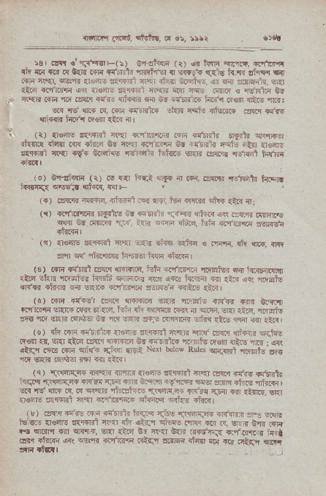
^{ntnFr.r} a,63, ttvhr. d e!, >rrr
lsr .'|!.tr'nr4r!rts(:) O-4at<cn (r) @ hqi <,!rw, *faq rji {a lrr f{ l{rE mr {dnr'fr rFrt r,!r { sw!? ^{'ft]s} _{h-r! al'I$r} qit .qi 4.4. ^{6!r:a} . .qr e ..r€ri _{r.E} .'i{ u..,1.. 4i fl a.rF.! €al
_{{4.4} ^{qr"ilnfi} a{ .r€ft a.{enl rr'aF Tr<r JN d4ro € Ts.rdin B-6 _{crqr rrli 1a .a!.r sd..} ^{,flt{r{F} ea id +rtr.$ h.ft rq€li lltF rB: ^{ql} rs' anr R, RI{ wndG llix rqls {d'6.i6 .z3 ^{rt'rs ql{{r} idir16€lI {tR {r ^{(t)} {€re nq{srnl {?r $t'l sriii m {r'6l?L _{n$td} qr<,fifqr itrftc {ftm rr{ .i{rd Rd r€ {r"rmF 0{ i{ffi{ nqtu -all {<F||e r{mt'r cRr r* 06ais rsffii lEls.o _{sr:lr igr.rr} ^{'.!=Fal} h{rr
^ (o) ^{€r'ai{!ri} _{^(r)} N _{ftr} j4qt ^{qr!{} rt r.i. .:FM rciRal" t{|qlr _{?Fe3} ^{qEqI} _{{nR1} qF
. (s) ar.lr r!f{rd, {riss{ -rE EM, ftq <\4{r sJls {t{ rlj {r) rorrlelaF FarlN 9r €nii? 1-{s {t{r{ a{ ta{m cTqE€ ^{qqq} nr d{Fi iik'. :{ri w{a si,'.d, fuli {.r'r.j.rr ?sr{si
^{(r)} {€N _{a{ffi.l{qI} ^{q.ri} Eir$ €ffd € nffi, _{fi} q[{,.nr _{4r} ^{qlr} _{"rl.4{er} nI,E6 i{4i dn rnl
⁽³⁾ _{.rE rt'nr'l !a{!.r} ^{qlrr+r{, tuli +clrr'6} _{"oiFirs} F Fr.rrrEft
'16 _{rtn} ^{qliuler} _{ffii} ^{q4r'r!{} r.rr {{c hrzql rfl r'3 !.r l.\ql! +rfq rtd{r dr _{sRn{ {'rBq6 rall{Fi} ^{qrtrE} .aF
^{(d)} r{'4 {{$El _{rwq} ^{qFqcl} sr{R ^{'r.FFtu} 1r{* rm Grnn _{idrrrr} ^{q{r.?} tq{q fl_{r<, ifi {h {?flT.c m nI snm, erai _{riF,} 'ftfiitu st _{re} ^{qRl?} i<]!rs 6E rit GrsE _{a"-.rin6r} ^{qh{} _{{ias} ^{6rw} {ir r:.rl
(v) {h Rr {'lltilF {r€iirs r{!r{ril?,qR ar( _{izrF} ^{?.drxr} $rJ{6 F€fl :{, ^{q.r} .i6 is{l! $@r.q s. 4{ritm rriFtu Fenr nto rr ; o<r etTJ .Rr r4'r s'l{. {iq _{eerl} Nqt berow Rul6 ^{qnirBl} _{"mlFln} aru
nE sr.n relqer r€ €r rti
^{(q} ₎ ^{'.il!rs]fF+} erq'cli rJHrF {€N lEFfEl nt'{t .sT.q +d€ ^{r4,!ntr} t{riq rr4irqaF $rc'Er TF{ €R oi'm ifr'i{r ^{,F@} _{ai,]n {k s} ^{,frtrR} , @ _{rd} ^{qF} _{d d} ^{qr€r?} riftlr-! rSFiF..r{ _{+r{?! {Frr} ^{ql} _{{t{rE,} qer .,sFrd frl.lr] !r? +rr?ar.{ _{sliffi} ^{qift$} iie,
(k) airy rniE Fn +{ffii ^{h{.a{ T.trE !i@{.r,F }rr.{} _{"F} s"! ..ar
_{16lqcE {€ils msnl} ^{qv.r} {ii _{{+J} ^{qilw} rffi ..r F, e.r 6rr t{r" _{t{} ^{qrfl{ q qq{, q{l} ,trd sr 4r1 G{r ?rv,:i. ^{r"lrr'r} iea erl .rR" i4 wP{ 4?r_n4 atfi 4r@ .nl!r @ .e odrF 5ir dl:| llSll
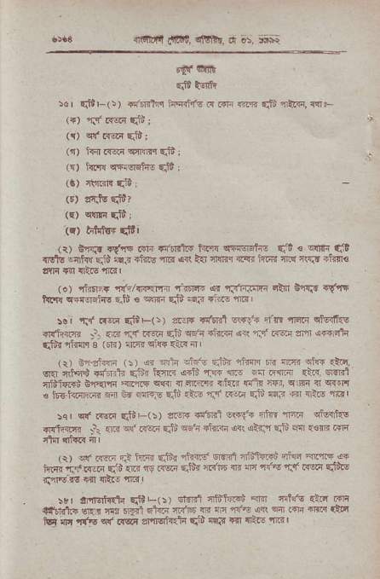
^{{]atfi} _{diQl,} ^{qlR} r, a 6, !r*
_{4r} stit
^{qr$} t{r,h
:6r ^{q'LF(\)} _{+t'rdhq tsqfirc l{ r5F ftrr} ^{qti} rtrr, flrF ({) fJr r{6 ^{qit} I
^{({)} _{ct' a{.€1i} qfi;
^{(r)} _{hrl r{eir cnMrq} ^{q'tb} ;
^{(!)} _{hn!} q,flqsttg ^{ql!} i
ra) {r.t! t'i .
(i) E''l!F {dr4 r{1r _{T-ftRlir ftns} qEft16ftE q"i ! q$ai q1l {Sls ^{rijfi{} di iqi{ sii.n {r{ aR i{ _{nftTFr 1r'$ hlrr ftq} ^{ql{.!} +tfl€
(o) _{r9r..+} 'ft} _{d{"Tfi} 'ffi or rti?rt{r qi! g!i;t .!'rt llFF cFrtqin-q eli € ^{*F} _{Eii} '33 thr5 {.r
_{!!r} ^{'rs} alzi EtiF(!) e._.r$ rltenl swrcr si_rr ran etm1tso ^{{R14iE} _{.: {1} ^{?i:} r--i f& d{ strF rq ' " Fr} m i@.4'i d":{ ni@ € (Eir) _{fllR} ^{qit{} rln rI
(r) _{ird1l6} (i) _{ar} ^{qnr} eids ttdr d?fl{ tR nm stF {ic, ^{gllr} rl$ dF t{ _{Fd-} ^{lnfi.c ,:5} _{"n} 4 t r .'.@ t.. lr/?i rniffi b'lEl'lr {r"lE E@ iI ril& rir{ _{{"2} 'ai.6 6 a @n s ts{ i<.ir.@ E1l 6d .{lFF F.fi {t! ?5 _{.r<6 Eiii aF tr 1ltc} 'lnrt
lqr c( lr!?i qttE(s) _{are.F {!ffi} ^{q!€({} nh5'nnn ctlr'nfqs rniclrn1 _{:\ .rF et rfirr} qti ^{qE'n} _{+Eflr} ^{q.i qkt} _{Eti} nar {s{R.*1q
_{rrr 1:f ff4} ^{E.1l'.pi} _{5:r{} ^{-ttri-} _{sTr r'B"ard} ry a.rF.6 6 ^{i. ir.{r} _{dd} ^{m} _{t ratt} D.ti? _{a"F} .1? ^{a .'fi!} _{":1} tfiin E'i8.5
5rr a:Ftrclfrti EliE(:) ci{rfi 'lf"ffi em flftr'n {lFr ffi _{{qbr'!i} ^{g1} r 4 _{FF1} .t{i _{ai'6} 5i .-. r.at rtF _{ffra d} 'r{|s ^{qr} n6 _{zmEltrrla} qti mF fiI {rt- tTG '
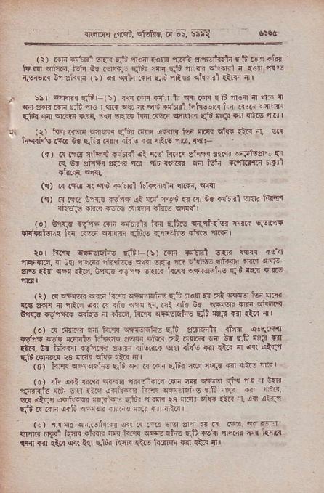
mffi _{|d,} ^{qtuftrq} F;S, !::Q
(r) _{@n @'tit} ^{qair} FJi {@ _{{3m} ^{'rJ€} a'ir.lftllr E S ls +t lr _{tut']} ^{qlcF.} i.ir dr _{r€r,r{.j} qt"'i rfli _{F.t'rir@} ot,{Fl n {s{ {{.r issr.i 61'eh{r (i) _{cr} ^{qctr} _{.rfi} ^{qiu''l]nrF} skflrl ciin fil
.\ ssr ^{omlr} _{51ir} (:) clE .in F{ I _{1i} ^{qir} m i _{t'} ^{'fl.fl} aI {3 n cqt c{Ir r{ri ajd rs I m eo _{ft} ^{qqr} dt'rl tshst|{ t _{i .{.F} L {-Rr _{sltr} ^{qal qrq,i} {Ri, _{ecr} ^{qe.{} if{ ram wrnn qlt m7 {< {ltro I t: '
3t ^{(r)} _{h{.€rn} ^{qnr} 6$:..rw ar@ _{tun} ^{qiq'{} clw {r:< ir, eR ^{:FRtn5} I-a 6i d.r .'rrrr 4tu , 4rr _{{i!s 1R.} 'lq.t
^{(!)} F {'!d nrh$ $J6ril _{al {d h.i. lfrr t na} €lrlatiarl {l .<. E !h?q s{iiq _{ra} ^{qr} {!ftn 6il t$ir {.rla{.r tln ^{ftl} "* ^{({)} _{.{ .sE {l} ^{q$} fld lEt{trRii {tr4, clcl
(,r) !{ r4zj trw idrr <i m''r-!a tr .!, bt t!'er1llnr irtr'r _{rhdN +r{r} ^{'rn$} {i:rnr r'n6 cr{(l
(o) B'r{r FE6 w{ {c'rrtr _{t{{ {.tiis} qrPr_sr r4r? sFTPf. !I({rlEI|{ lfi ar.rr cnrli{l .Jiio r:'n'.t$ _{.trc} qr$r
ror trfi l@.Eti, ^{qri'-(5} rfa r-r.f sr {qt rt{ ^{'lln{l'llrt} ir -a _{rF.{.} 'l1rrlq€ ^{.w} _{Ei{li {r !nnS.} ^{q.,i"ra} lEIc sr,- aIE {in c1.1 _{€.q, o'lTF r! ri} ^{q.rR} _{i<irr} qtiErqhs q,' {!iq ...r
_{ti) r{} ^{olFr@} _{{ria :m} ^{qsr:r€irE} Eili Fr€fl _{{r dl} ^{q4st} rq dia, {ar sff{ n rR.i lir _{.{ {rj3} ^{qfl} :r, .ii {tu _{E! ww .ni} qii.t< 0'l{.. r("l!Iir _{c<f5 n +iilq, kls} ^{qa€Elie} {id {tF {{l €& {l
{o) 6 .i:-ri ia f,]lr vq{er.h. F.i"' dirqak {t4 dlaiiert wris 16{ ni{itF trt{rr+ a.sr llni .ct .rffi 6nl 6! e.t"' leir !?T {ir{- sr l6i.l1t +d"riFr 3'm _{<riB.ai"} ^{glq} ri(E T{] rir _{ri ,{{} qta;l r$ r{lTd.r $ ir!f. cto{ *Ir rIl
^{(€'} _{h"1! @a:r} ^{i} r _{Ea"} ^{q} _{r! rdi} ^{qi@ rr} ₄ tn ⁻ a>. ! m, (d) .t" i6t _{@.rq} ^{q@} ry @ _{a} ^{qrq {'{} " I r
r?<r.tu fr :r rrr.. !ft t{n !a d 5 tt '.. r ,'1?. aiq _{lift d{nn si.'l-} ^{qfu',} { Fl rs _{fl.nr} ^{e:{a} _{*.r} n. oii a>,q ^{qli} R _{.{i} q+li ^{qlm} _{im! arF {i} ^{q} _{e.i} I
(e) 'r1l4. ^{qri:isJs:{r} ar( R r+E
rinli' n$l ft{{ +ifta ns _{h.fs} qt{sqhE qid rlfir{qre m l{r,r{ ^{r!a!} !r! at{ 4$ _{hr} ^{qtir} knr< {t6 tii{qq r{ {ta {'
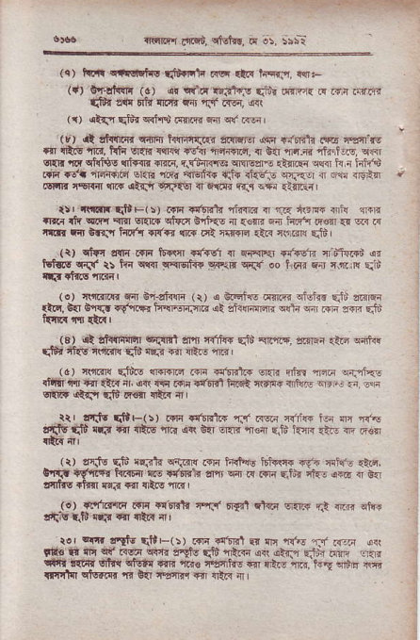
^{rnnr(ll} _{crci,} ^{qH?r.} !c !5,
_{{q)} '.(a dEl'hs qi#' _{.n rta} ^{r,E{q} M:
(i) otJalrrli (c) _{{r} ^{qfd} lqil1qs ddr i{r?.{ .q rni irr.rr Sth arr t'tr $6? Fn {.i' .rF, d:lt
1r) {td{ qtdr ^{q{h$} _{tq}rR a{} ^{qf} i@'
^{/r)} rt _{!t{.6r} ^{qm} hriFir, eFE- 6 T. F r FE ren {t _{*r !fts} ^{'ne,} ht{ EIIi {q!q itlr ffirr@, {r _{6{} qr.r.r{ 'fr.ii.j, q!3r cn{r _{!F} ^{qftins} {tfm .m. r.tu>{ns sNrs{{ _{rlffi} ^{qq} h r iifl$ _{.iF re.a rl6_a.tF elar n6G} ^{'rrEtr.} {lF cla€".s wi{.r { rr <M,EJI rsN'n l'Er.{ cF ^{4liJf} _{_art€r} { flrtrr c{ic vfi Qrl.--<r I
llr irlEE qt F(:) .{ii }llr.1 rfu{i? 4r r.'a isF r!i( ?r+ri rrrlr _{fi} ^{q!fi} Rr.I sRnt _{ciiir} ^{grt{€} { {€m 6a t{t'{ F€{ a{ c .{ tilrr ril 6r{n h'll{ +I{F. @ dn irrsri .tr {e@ qii,
(t) ctln a{r{ r{F ir{llr {dndr { ff*rF{t Ftr€!1i flilF.+i sr _{i.f!.s} ^{q{rf} ir _{ii-d c{{r} gqeriR ^{6prF} c{{ oo _{LF{ Err} ^{q.rr} rq Eiid
6- !'{@ , _{t/ i} ^{qFla} a(q req Ei :ir.
ril.t, C{ d!Fi. atrF ^{eqd-:rc {t} _{"ft!-ffi 'i"i F. 3 i} '@ _{si} .
(3) .rt _{aft{riqlr} ^{q_^cl!l} n'1l r{rnF di ar.lrE. !1,:rlg{ {tra c{irc _{..-iA} ^{ql5s} _{rlmn!} qiu' ^{qqir} € $i- m l
(d) ^{crffi} _{Sids} w.rc _{.Ti rrffi6} q{rr ^{qfrr} _{"rd.i} qailEE rltll'ina{iriiL(r _{{rir.raat'nrlt{diFrRflirc} ^{q}i".i ..i gl1rF} Q.rr ..td e3|r lRr{ ir rrr laf,s dfF(!) _{r{lr r{r]!lG,r..r r<E.r} ^{q{jF} _{i.r} ^{q} a{c rFqtu _{sfi} {ra _{Er rft\r {a} ^{qr} _{0n} ^{qnr} r€{ c.ld b"ra .i- @ F€n
(i) alils qiu' ^{qa.rtr} w{r{ff iq4 ffi€ Hq!{{ <i- tud {rad, €'|r{ {9,ir{r ft'ar{ ft {r't6ji _{?fl'} ^{qir} i{ r$ri F:t{ d{r !{ir { G?r t'fltts nt{n _{lqn} ^{qt} _{nt} q ^{'1l.{} |
10).ri'r6ffa _{r.'i i!'6Et!} ^{qq3'} _{ry?]} ^{qka} Enr.f F.n ftir rffF _{niiq} ^{(tu'} cr.? ar {tc{ { r
_{r.r} ^{r4'|} rntu ^{qirr-(r)} r+n rtrFRl -r r]{ _{d,s} ^{.jj} r{-.i €{l FEn fi rt !t' ri.n F r Ea*) qit rlta ^{ii. .trJ} _{d} : _{re} ^{, n.r} ldir _{!{e dlr{} ^{qi@} @ ^{-h.} 'a' _{ir} ^{q qi_.r} _{rt',} ^{r.!} sri _{r} -e _{{r,rrlfl} ^{qi'ftTd} {r ta ffi d otc 4
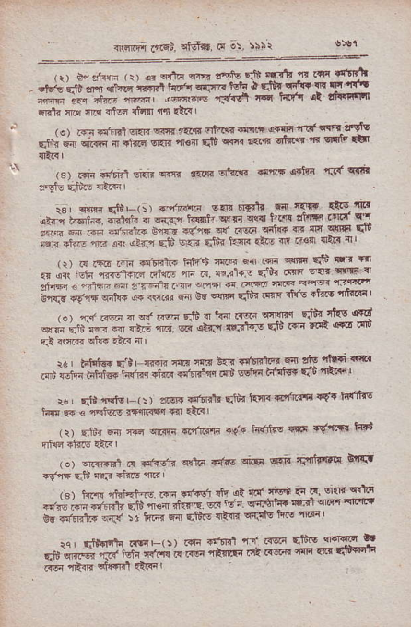
,:, oq:Jan,r !. €ntE diilr t'dE Et {t' n rtF 4'aE! ^{".J} _{":a} !.* _{i.."r"} ;#a k''- _{Ga} {€t" _{t rJh-} ^{qir'} c _{E} 'G'n
_{--; ;" arr} -5.!r d i{'r. d 't*-{rt' Frtr tu nF ffs !tsnr flt tlF I
_{,r. m} ^{qnr.l} em Elr _{€F.} -tT _{.d '*'t! ,i!iE} ^{q-d} _{E} ^{F} ir"\tz ^{.-t'. * ;*} " nlrr" _{srt} -€{ qid !@ ntrs 6t{.$t ^{rc} _{"fi} e'r {s) r+n Tffi _{sr.n} ^{qr-.T} n{i.F srfri{r _{.!trt c.jii {.'(} qft
_{rnr w *tl'-,:} 6-/F"." E{r.6rf! 6 rF _{ftlr} r_"r _{"i} 'i' ^{r"-t * fut} _{" *-'r %!qi} ^{' q} F aa.] 1-t{ f"? rrrf {'l
^{:,'." * * *'i+r wir} _{",''-{} & @ r.:i@ n F irrg G ;"*-.,i i.r FJi 6; Fii" ^{ls} _{"n} nF€trqtic4 _{+rr.+.} hn,s 'nrn @ q ^{q@} E$ c'3 4
_{a 4{r} ^{'qh} f{rfc _{a'f} E _{t{} n.dt!:r 'ih
;* _{".r-} -. z r--\ ,-
_{c'm <*} qtrc '.+ ^{qre} a _{Gd} !@ _{dh} (@ _{'ft't} 6'<E _{n'tr'a} ' ^{'r'} _{Foa rji} a ti _{rft:} !lI@ Fji{ 4'e {cd
sp _{e'd} r a _{- rtrr} ^{-F,} @ ,an s3'N rJA
_{>a atuird r- 1, ffi4 m} ^{'j:{} E ! _{d!t'F} d _{aia} 'tE 'r'E _{.d ;hi ffi irre} .'4. _{';6"'*} ^{qa} _{sEt".itd{!} rii rnin ' ^{:b' {c} _{"{ts} ': ,tw.tr6r+, _{Eda tr} q'ftqE tft rt'f{ ^{j"h} _{ft .} ,Fi'(! .${rfiq r?r {ta
^{(r)} _{Eii.} ^{qfi} 4rd cn:.rrr
€"rr6ar {#4 iifihs _{a_a6} q''a|h iq"'
_{(.)} ^{qi@t1} F +t'{dn _{c{liq} qdrs ^{qiF} sEi _{ff@i!} 6'f{t .6rF 6lt aF ^{ai6} "nrn
_{ar b'! ifitEt% m Fi+6} il' dl ry ryi ri r| '€t wla ^{a';m +nd'l' dn} _{"r.-} rt,fi _{F?} ^{'E} { dr:tf4 sF- _{dF.} qFii! _{c' {'tElF} ^{qr:r} :il hir _{s} qt"'t_! _{4tc 6r&' 4} '''r;: _{:4 Eta6rt{ d6' \>r} rdr _{rirtnl} ^{d} 6,ra _{r'ds {ffi} at
"ft';*;';''.i-"r"*-;'I"F t@'r&{r ffi {tiril
^{-in;} r" _{r"'-r} 'm F'a rJF-'r;
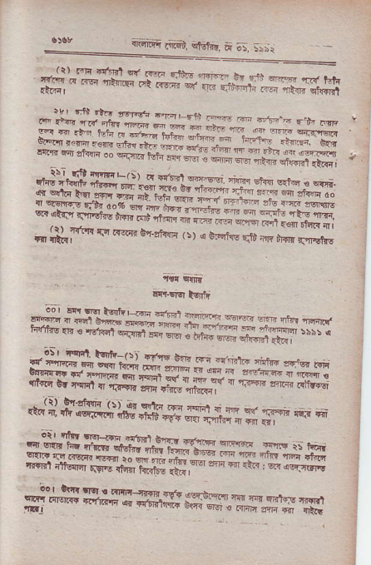
*s'_RHS"{,R*'sE*##RJSS ffiffi
ffiffi
.i _{li;rel!} ^{qq.{|.rn} st".ahF ^{,!) e c_Flrs Er} _{"!,e} ar!',i"drs
ET'I.EIEiffi
##fiffiffiHffiK{
r#ffi
^{#;t*'ffi,t'rd,s##i*fi} g ^{y'} "* * ffiffiffitrffi
.#"**##uffi*ffiwH#HH
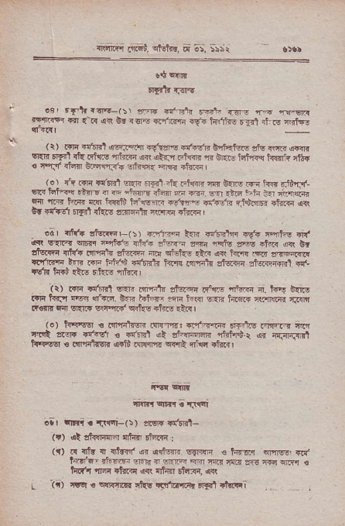
^{.i61ffi} _{offi,} ^{qlElrd,} d= a>-, ar:r
!+ cm
dE tr -3G
^{.r rfLf@-r5\} 1'F ^{.'th} ffirt
^{d-3er} f{ r d {{ 6| .m 4rfl4 ^{+Fi.nfo} _{rr{' 4 @} r.!?r
(>) rrF.'l'3t !a.l-F $v.eft.'!g4. t'.qlw:ro as lsdr 6El' Fra' _{rt t'iw} ^{-'ir@} @ o'-r Ftr@ s t-{r, HFv i@ ^{r} {i{ 3 nrr ^{.t4} GtGn:r'6 sri.w tu rd_ffi |
'. ^{t it} ts _{tt-rn} ^{.r} _{Ts'} ^{.i} _{F.{F @ bru r} ^{.d} fjtfl _{6F h$ft tlc} ^{? F} _{"!Er€ .rrdn} ^{r} _{i@ @ .td} ^{-.h ]' 'r. ft} lr{! rFr ft.ar w lrllrru> tr'llJ* +eiqE l'rh't1i rJdlm ctRr (R C! riod _{rT{'t rkG s'-!lqi'lr iffrci} ^{'rtRq} I
oer {ftt rlqrFF(i) €'nFi kF.!dl'lr ss'{ r?if-6 lri _{€{ !'{E{} ^{qr6?.|r} rqiqr5 d.6 _{31rG sc.i nqto 2e .trEf} ^{(r\} bt zkrln { {{ _{Fffiir af!t@ ftr} ^{qR!} {te o{ frin< ,en 'a,q<{cc {'r'FF }* nF ^{iiffi} _{"!ffi{} h.{1 inlrlF Ekni zi@{{rnl a{-
rdl' h{": !t6 rla6 afrR,
^{(r)} rq" ffi !i.r. _{iririrr stuFq{ n\F} ^{'']tuTi} 4. t{"{ C.nq i}lr ftTr _{rEir} ^{q!r<.} !E i'nq- ?qli t@ sFR film *rFrq rFl'l _{ll3ni F{ sl{rir ss"'llrd} ^{qifus} +ffls ri.< |
f .j hirlsq € Nr-i'ac ft."rE: ^{d1_n"@} FE{E .rnFre rc ftit lt-rr r{..El u +{ffi ol ^{aril1rnw rtt{t} _{r} ^{q.} i{,{-.{.t _{h.{Eq 6 rn'ntER u+1t.q!'m} ^{qrrn} fli6 rtor I
_{{rl.'r} qF!. 'r|!!rt
ol |l'r'r . TIr.i-(:) z!!F rrffi-
(!) ot rfcqflr'r {ftr' Elcirn i
($ t{ rf! T rffi ar o{!F !!ll!n € _{hTd'r} ^{ql!r@} Ba. lei"q-' rlrFF _{!1.n {} ^{q.llFr} @ crl! _{flin sr€,rTc} ^{qn'"|} € _{tldf4} ^{'inr} rh?ii e{ {iirl 6t r{{, {{
_ ii) Er ! s${rB ^{r'hr} _{'q} rra'ft rd t'trE I
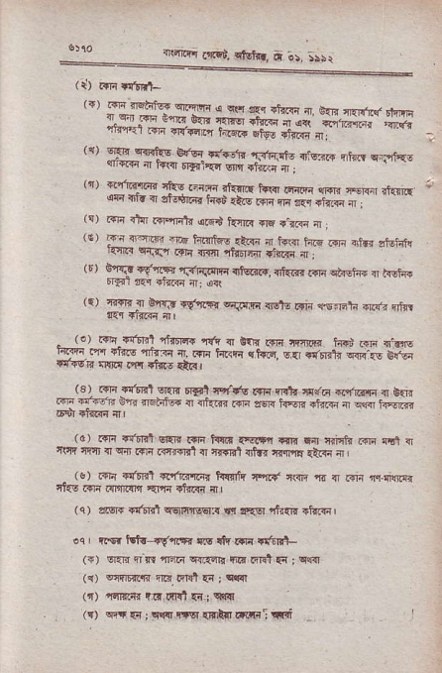
rF) nE ^{nqaitgrF !$aqrrr{ q qlr} Eq rj,a r #
" _{ffi'r} *F _{r{n} e".."
_{rrt'q} u'; ^{4 ;G;:'il} #"#,H _{,zr t4iEz+ Efqs d.r; { .}
'' _{mTRHg-#} {i{.o'i6 cjrqi'{ nh.' c*t{s ^{rl) !.'1tr.@} rko r:E at _{m} ^{,i!i} FqF aF, ^{eai. r.{nrl} rn irn { eronr@ hri zai! r-q @ ,r. ..rRi ª . ^{(c)} rsri rt{l r$Hi1, ^{q.rd} t n { _{erE} ^{q-r|r?} ir ;
,., _{31"1..} ^{.16} _{fnFdEE 'i@} ^{j!6.. h.e} @ ^{.ini airji.F} .{n ^{ir{(r} ..i .Irn ^{-h} r4 _{{{rri 4} . r) a*-i .9,rF4 rFFiiEr ^{+qn} , _{dr.,r F} ^{qiisie { arEt{r} FFr !F .i.fc {: oq (r) {trF 4 oTrn _{{d,r.'r} ^{q.Ff,,4stE} rrF @FtJ @ri rfur
. ... :-'-f6ir,:l5@ *{, a Br., rf,r,t",m i@ @ q,nlfs Fi: i? ^{.Fr'nn} c { _{@ ta+i} ^{qtorq,} e{ erri.i !@ (E _{E} -ra _{![wR} ^{q{xr} nr +i*. .!i! |
rs1 _{c{;{l-rl} ^{gF} rFt ^{'-,r'fq} ma _{nh s/F} ^{q"nirF a b.,} _{F"} ^{---.?} ;rd €i;i- . tu @ rF \E r?6 4 @ t r.,,
^{(d)} FF .t'nr'l El{ri rrrn h!i* {€!r,r iqrn !fi criqt{ r.ii crl { t{iE ''n, { ^{qrr} Rra ir'rT{Rl{ rr{lrt rrtf{ tfl,rr diRc {l
'c rri.n'ir_.i {Fet.!..' hqrrr rq.!. ffi rn { r{F n..r-$t'{ tkE *ri rq],ll|{r {rqq efuRa ir
(q) zrsF 1n ir'rl cGlmrs€tn w:Fqr rtur:ff drir{ |
.q nq ffir-iqff{ liq .tr r{E r$flr}-
({) _{sr.rr n!! nF.{} ^{q{.{cB} nir rrrr'l {{; qq.{I
^{(q) o4rH.fr} n !. ifllt {i ; qr'{
(r) fir|rd{ iI' dr{l {i _{i} c{t[
(t) cm 5 i cw ttsr {RlkI fitq: i$i
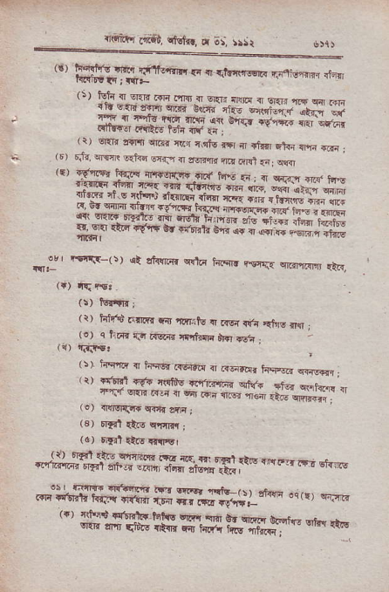
^{nlfi.r,r} _{.'|iii,} ^{qMr.,} a ;:; ,!Sr
_{{6i} ^{.rqfs :rr} trfferir' !-, º d.!'F€'i. ^{rncritr /:fl r{lqr6!} tg : t{rF
r'.,{q.iFq,@rl
_{{E} ^{qrt} _{:fr{} ^{qE{r g@ ?lh .x"!;} * r' ^{*"rt} ".; 'd;., _{;;- r 1} ^{c} !'rrr 'r
.f"r- , '"rtr! t-1i ;;\. ; ,
^{(i)} er{r rnrn ^{q.r.} ftr r\qtu rq { _{dr{} ^{qfti} lm ^{+.F} l ^{(t)} _{r;r..} ^{qlqR} _{G{i{a} ^{q.:} { $.8$' ^{n,6Fl} _{{{r} qq,
^{/r, 6f}?l"} h€! ^{'i|-.,jv6} ft{ t ! , d s,.-_\, ^{d.{ r4.o rnnftq{} i{il rr.r{ .*, {JEffi ffi ; ; _{"rm,i} ^{q} _{"(r_.:t';;-.;.-;;-';} ;;"#f;.aj
_{T_.w_:-} ^{+_'r.} _{"r,r-,...,i" "r,qe.} rr _{b.} ^{j .} {{; _{!r. s.rrd} ^{dFrF} ffi .i!., ^{itr _} D ds C.€ ^{ibro} h,. b6 _{*Jl} ^{*.v"'on**t} 6n ^{qo} a s;.-r drs _{,n!Y} ^{I Fr..T-(s)} {t zirftnr cdF hrir, re{. ^{c@r.{rs} {aR,
^{(i)} hird trrl.1r {dr rdritq r rlsr l{., ^{,{fre} *r j
(o) ^{q} tiri? tJr aEF, rrd?$? drf @-n _{I n' qTt|$r}
^{( !} ) ^{tirfl.{} sl his, ^{RE{"r!} { ^{irnrd.} h,rEq ^{qn!*1} l rr ^{rrtrrl.E{} firldE _{*'rnf,ir"} ^{qja,i ,r, *r"} *;.." i.'* ^{t} " *i,"1'.; *- :#T: "
^{(e)} rRNrfF{ ^{q-'k} af;
⁽³⁾ nfl ^{{ae c,n'll} ;
^{(a)} ryr1tt.E rfiEr
*#iffif,*Tig,Tf1*Xge.6',.".':r ri." 6,fts _{"""ili,trHJffi ffi ffiffi.;_"t} * ".,", *-" ^{(4r} r'Fii ^{fi'6httq} t6t(E ^{Elti!} erfl ^{Or tu #_ .o.} "* ^{q'an} {|; ^{-*'hF:;.";g'l;qfl'} "n'',*
^{rMRt'r} cl(t|, a'Ei.r, Dr o;, ):-A
^{(i)} _{hk!} ^{qEtr} {,ntr ilnt hrnq n n,!r !!t* rrli *r{n na ir.Ei .r Fl rfd rr.i{ lgta"\. _{r4f} ^{qRr.. rfu |'rnrFl} : 'tir (r) cq.!r{a. (r) @ cd6 ^{!fq!I!} s,rq{ _{Fj} ^{qft! sE !,fdir} r{rr @ r.E {rTE FLr _{fRq {fiiq4 @} ^{q.F} {tF're ^{{rq,l} lffE {rc,F ; _{s!{-i!'} ^{q't.} .{, c rE orw {Fr+ {l.!.. r+n r. n. . b i r.{ rqfd{ \, !, ^{e=.rr o} i{+ r3.1 1'r 3r1!l.r irg ot _{aE} q{r.| lr{.f,J f&rFr lnE vrl Etr{ il
(t) rr rfE c't€.rcri (! | 11) ^{e{rl.' wu.trn} rn t' Fa ^{hrrlr{I} Fart, E-rn ^{,F} _{B^r} ^{qi-"aFir} iT-.i dqi rE F4 f,d {f,r6d lr'ri! !rc (o) 6'lat{{i (r) @ c{rF iJts !E _{si!i,:} (!a{F, ^{q,s} d,rn" _{r<i F[!rFr'} ^{6\-r+r.F.u'} @r,:{ {ffi ^{,i r.fii dnF} 7r 4lrrfi ^{r{t} pElEff 6r arwrr:n €rR nqr {rEI m rh.f, FtfJ cm,,
_{60"r} ^{I'q} r.|r _{rE !4Er} ^{rr<i6-(s) dt} _{af+-lrl"rr} ^{q!l6 r.i |{n43 l.} _{irl} ^{{rflrrl} am f@ .6.d {y@ _{ft} ^{.,lEnt ffi F@} c!, ^{6l{&} r{4e1 w! / :-'rft .r@ _{5.F} ^{.Esr} qrqF ^{qr6E{ c6n {i,$ sn,t I} _{€f|} j ^{slII} _{{.ar} 'ef1r _{r.t} liErn ^{ai.r} _{il'IEr} €Flr ^{5<Edn-4,} d.!, _{trFETr} aFTG{ {{r olgr{r.Fr_?ms ^{qE frft..,n} _{ft4 sPl} ^{gM q{ .{iqfi} Drsfii ^{ri].f} llta it ntr*,r ^{TliFt} t{l.r{q {rrr _{Lx} qRr cnn{{r ^{l.{} Ftrr siF llfi{q : {{r
_{(r)} ^{qlwi} rf! _{{Vr i4rnft} ^{qiirr} cRl |'irrF ^{tfw...{ f.E @} Eirir {r4ri Nl ^{f€\!} {.! _{!( rt',rel.{} ^{,r.iit,} t€ r'lld _{rulqEay jri..$r,r,_R} ^{|rJl:ri} 4&n d€r, _{r{.} qqll ]anrro r@ fiq rari &tqfi Fn T .trfl ^{qr.r,} e(lr..\ ^{q€ glr|} _{{r.rE} ^{'llrlrfi} ;
gfr @ .r: fars rqF! {r rf.iq ergl{,, wq sd.q _{ry ry} ^{q:r*} _{T. f'"} @ or!r., dtdr cErF,r _{ri(q rq a{r {TF4 *+q.T hilrm} ^{qtr6, '|llft} I (tr Erorrl ^{d,e=} t4f , {tr. F ^{6r,rr s.Fr,i- r,!F-} n{q {idr.r ^{Eqr.} rnrf,i rlq 611Fl ^{qt"ilr} @rEr €q -6, 'rs lnFrrii
".(.+S*
* :*: alqrri !rt"{ ^{'rr} r(r''rqE ?',{,q
r.ir_ri F6 _{frri} ^{.q} !. F ^{rr\ i} r!. ^{., rf.} @ 6frzt,.r.r! ^{@ @.rF,5n .?E} ,., !d-r ^{4$ dr !._} _{r.} ,i>i _ er_i* _{tr?.} qn-" ^{a'Etn'. llE} "$ r @ rrF. d Frr df-i_ ,
_{(r)} ^{q-lBrs} ir'F{ irtu'n ^{|r."F1} r.r re: 4."sn nq ilhi< ^{ildr €i1.i} _{t{} ^{r*nrn} rliF 4irrr: (c) ^{qfE{',n} {tt rftdrsErE _{ffi{s {} ^{qtd} T _{ffi rtrq} qFhr
l!) r.6El r.tqi.ii ^{qfa{r} {trr Or .vFn im _{{tF:} q{{i (r) qalltn ^{(;) ({)} r € ! ^{q} rirt str E4iq ffi I ^{qrwn} a{ie rtq se{! ak? rh6 ,,,5,,c){ _{{1116} ^{q{'} t! r+n +s m l'o {d! :
('t) _{F,ir!6al} ^{qfsisir} fl{tdi _{rir} ^{qtuT.<} ifr ^{Ert dca br afr@} (\) qtlE (o) o _{rht rEt€} ^{qrnn} _{rtr} ^{qR qlgm} ddn {tr4 ahffi ou(!) (+) a lhrr 6 .! iir? N nii iJir<
_{.3:r} rFiEr 'M .;rn Er.q nt{lnni ⁽⁵⁾ F.srd m rt'm{lr hr"-x ^{qt} _{a'rlldnn]n} ^{qqln} .ffi fli1{fl T.F4r _{ii.c} q ^{qr!} _{#F} ^{q1,tu} im iF _{rc,} ^{qiwtr} 4fr .n- _{!-i} ^{?i',r} n ffi riF - rE -frF ({) ^{rdEmrffi} _{?rlr{.ttq} ^{q<!} ?'qdi-c ftcr hs Srr tF{ ^{.?aa ,aR} _{R} ^{ir{d} _{clEi{of{ i6tc-} ^{!turEnlc'B} nlE dir,i"- &r+ _{tsFriq {rr r!,"r'F} ^{qiral} ?lnrr _{cm} ^{qrl} w n{ rtu t{irr{r @ ^{'F} r" @ _{13 6n!*.} ^{-ar,} {.rF
(r) ^{qk{,lrlTr} _{afs} ^{qq} d6r{ {iL r.tB 4rt' k<}i _{rF,} qM6 ^{rq(n rhT iita!-} _{ffi} rfl rtrF a1 ?ruirE r€ ..rr 6aF _{c'n} ^{qrtrq} m Rb _{rr} ^{g!n'r.+} {-{ cniF e31 Ma dtir6.r ^{rF4-li} +E ffic i'lF idar iTr€ $Fa rfr:
s.1\B'qlR d, ir{fr6 an't eI< _{{l{.} ^{'r.rr'} Ets-F {tr rii *n.Jv{ _{F{} ^{qr.if{} rrnd E{t .l.a _{$fns or@} ^{qfaR lih} iid6 r'FI rfln f{ !!i,s an' fin rrE r{r inc {tiF ⁽ r) .{ rtr. stEr5 {ir hfihE { d(s 'tm _{{s} ^{qqm qq{n} ilis td6.+rf@,n(F.qtsd.{, _{'.d.,} ⁻ c t@r. {*. ,.-, _{ffi} '@.h, ^{.ltrn'a} _{C@ o+ qrac} ^{r.'lm +} _{ra--} ^{q} _{r.F} ,ii"
({) srF4- $rdn hr.F niN +rd|Frts slF _{{irra} ^{'n16} .ln {t eu ^{tt?} _{Rr} ^{€'4n} _{.llft} z+F. rt
^{+qR} _{l]rt} ^{6tui.!} Dl ; jasi
_{It)} ^{ribfn qlq} kft itF turqf+ €r ,'_ a+-.t-T'*--";"_;';;
:"* _{""-.#"--r} ^{-!-} ? ^{.-- .fl'} '!i*ffi'!-'+-
Ffirrir ^{srfo} _{<Jrr} qJ4?r :
ir\ ut dEafrr ^{stfuf-} r",! _{fr-} ^{.* Er!} F
q{"-- '_ 5 ^{.._-;-;=l;: :'it} dtr{ d@ ^{cE f'r+} r oi$ @, ^{-v} t4r- _{t} ^{.4. 'rdt} |! _{ftr} ^{qlwt rt |irar-} |-+n;;;'. ; -; _{;";;".=L1*"} r*
"d
ori ^{1*=} "-.r.".. r r ^{#"-} " _.".,_ ;ffi *l _{- ?F'} ,@1d.-,.r6r-
^{,r-,+r +--} _ _; *::i;**-.-- ^{qF,,r _n *@} ;; . ;. ^{;_;-;} :: ;;T ₋ rA) @qi,t ^{dr+4} t !fr
_{9d} **- ^{-e?} .: ! _{":-;;"+} * '"-
d-.Fs Err! ^{n6} _{t",i- r*"*=ff} *"- r!) ./ft .n fi.er.\
-. ^{F} _{?-} ^{----.-} _{%.r.-} ^{..- * -} _{;_:-} * - .Fs ^{-d+ft} _{ch} --.--+;*_"
^{*#HH-} _{T,*,--tsnn'Eqr} ^{.tsF q} !tu"_ ₋ ^{.,r @r} d+iF ^{*to} !- ffi ';,.' EF,E-i*
;" _{* ; =*:} *.*
" -.'o *- ^{ot*} " ^{-#} ;- ;;;l;?1",
"
^{(r)} _{QTJi} ^{q'ri GnE +r{.fl} i:lPFt ^{+}.r,riJ} +rl
_{e-!} t 'lE ^{arrl} .* o*.*
..*. rc r"i,}E _{-;;;} ^{-;;'-} _: ^{-r*} * c.rq-arq*;-;:
rr) ^{lPbdrt +!.+!"r} $i rtlrtr. qF
_{lt)} ^{qrEfj r/ti} rll _{?E} ^{q.1fr !ll# _ * +} _{"*-'- --.} ^{.".--'} _{-'jl :_} * "'- ^{er*-"-;;!;} _{.;;;-} * *
(r) ^{!@r} +! lrfir', liEt'iB ..', _{Tfn .llfl@tl} ^{qn mi} €r drn nfir 4 ^{'Eirieirl} ffr r]f.n ^{,{sr} knF ER ^{en qnnnfi} lftr : (i) lfR-ffi _{rrt'a} qEa-c'Erq]sd.n ^{q.F{} <,r.F,dt ^{errE} 4ntlr€ mr €jr clr1Tnl {iR, ,rr +a-,r- +tc m.q.. ,.q rq qE 6"rq ^{r.rr.n t{{!'RsErr'} iro _{Irr'rR} ^{q"{} .rr4 ?ftrirl ot{rs F3fl dr{ arl
_{.- ,(o)} s'4ni |r!r1, ^{rn} _{-H,iiq} ^{.rrf,,} ..l? hFd {IrlF { ^{.{n} Fmlr ^{ar$ ?.r.} _{"rnr} n r{q _{ntuE} ^{q,r1+Ir} +t"G 4ir.nl _{_(er} 6{Ef.1 _{#r t4"} ^{qf€t{?"} a{iftr rF,rfqr b,{qnF{ ^{cil} .l|ri n rr'r {rra n{ E.tusiih@| rd) _{eN@'4t'} ^{g.triE} 4t r.{ _{{l9$6F} ^{qturn {fi 69@qrifgc!} {.{l r _{i:} ⁽ !; .r 6$_ !'irei er riE d.r{r 4*ii} rcr ^{.hr irr{i,} !q eFJ aer rt@ ac at .r'*F s a. .e.s'' 4i. h, xr4 ^{6tr. rF} @.-ffi _{rr .:rk} ^{qli} _{6r i@ d6r":} ^{.,\R} ir,q 4+rir? !{ f, t rrrr rq. rrrd ^{r!} _{"F!:.} nli=q {iE, .F rrr{n r} rqtu 0, s@ ,qE rfoTi.
_{r!)} ^{qE6Rl} 6N' {i' ot rd ^{r\$} € F, 6tdre r,frr .m srEE _{irtu F} ^{qr:rffn} _{F rt-F hiii} ^{,!'*t6} ?iFrtr+ rffi € ,nifr _{Itfi"@ -{iffi-} d, i@ii €*;r. 6.., -aF ^{gEs} '\n"ir ^{eFJ} t{.F{' {ii6r sirlla oq r l ) 6ar.{{ ^{6idj.} _{"ic,} tarJ{ i:wgl.. iE {rfl r$r
(q) _{srerrn} ^{qtu'} _{erE rrrt} ^{q} € llfi {Rfr{|rr lis El{E lrM drw zlll.E Tnrr.v'{-r la.d.-" Giriql
^{(e)} Etu{c {'lr mfl { i{,.fir i{qf wT &Eri'r3t EqErrl r{tEl _{ltdi} ^{qtgtll.lE} Bir {li h'qE anq _{atura, sa} ^{'rd€} { Tir t{q c'qrC
(!) {d{4.qi LG 6rr,r .id @ dft1 {! zJ{{IItrt ^{qda} {q Ercrnt r''.6 lan ffi 1tnF lsa {id ff<r srfd 6r's .{'s' tdmt _{rii.s r,t{nr} ^{qR} _{.{ .ra} q,:f-'i ({{ Erc rf€'1".{' rn {d. ot .ta @@'dl .I!6R rs ib !'<@ rsqi ,n@ ER 6rf, rE€ Eqqr _{a!!ln} .T|I nn {t!il
_{.5o) brrtu6 r r, @} ^{qdr} hR .{w_r rrlr a!i{+ rfq o@ '"m w:ir{tq |rrt'r !! _{e-is-{.{F} ^{qf{'} { i,'@ rrql sisqE ft! d L(!I !(,Flrf LlF a'q Bgrr rsl {t\ fll
*ftryffd-ei.;#t,?s 4i ^{rE(6 Cr Rr'nTL{ aFj{€?} ..F Fr{E _{r+.e:}ffirs# l
_{li-:]ll@} d!,.8 :ft_F ,.16,? ,ti ^{rta,} E !1 ^{dF{rF} €tE ^{e} " ^{r-.r qfae} o:q @ w ^{F?} _{€i.€rre} qhi _{R-T-} * 'rna 'tG @ iie! tsi! _{_r>\} ? E ^{@,n1r?1?,+ _i:,} @F, . eqryc+R,s _{la""T} . _{T'.ril.} n- evE 'a, ^{F} ". ^{e4Fi} @ ^{.+5.} { :-"1- _{""1ftla ,-} ^{,1} u 6, ^{']fr -{":r} ri:..-J- !t i,qs _{ed} ⁴ _{r! E} i't.*a :-p ^{tE!_ _-._} i ," ._ _{rc} ^{-an -.'r--.p.crn} _{I-q?-} j.rn-_ "
_{z} n,F ^{F@r 6rtFm} @.s.-?- ^{-_ri-F.ft _.rr ,+} 6 ^{d6Er} Fr!.Er.r ^{l;} _{m} * ^{q,ni} i+ a;;. ^;; +\ ^{i.r"} ,F.@r qrmqdiflrr
"-*igg1'+**-@rnrnqr{af,{rilhr{€
" ^{f} " ^{'".*"" r} rd,@ _{.'.f} q.!. ^{--|-'1" /b!} _{e".} ^{.-'-,T.+*,+?'} 6r-it? ^{/,.l!..: 6+qr}:B Y:r4!r} ?+: ^{.Jp{ r} _{"r-} ,}: _{"^ !-} ^{._p l,} _{"J:-inE-q} ?qlr
_{*s" :!.i"'} : ^{a!"^h-,,! Tfu 6.\} z-n,F'Fltrt'r" _{Ti} *." _{-.TlT.*"* r} -E-r.FrF ^{-.-,-} q _{.:=} ^{..- _-d_} a+i _{r} q"-lr
_{rrJi "'-} @ dF _{nt} ?:? _{ftrd!,} {r_+*,r!iddr
^{*.Hl} _{#H#ffi#ggl} ha ^{-F.t} ortrh,r i"{, ftlra,
. ^{&' 6W 'F} !-slro ^{e;F l*ra dr n} _{@!qa|} ^{q,Fnr {r{ -;G} s-rft ^{6!@ 6{F} 1{l+@'r'-+q' .eE5.-, ^{.-'-! -r-i,} f;-- -ft
_{:iT:T} - ^{tu' r:t} "":" 'tF .* -+. .* .m D'F _{T'"i*.to 4} ^{qE} tfr t'E, ^{. -...e.-} ;h 6"F ,t:nr ^{-Tt} _{€r-} ^{,_ 4n} _{A- !-} ^{-+q q tr d-ql .a-.p} ffi '# iq _{r} ^{q ..E} _{6!} ^{!-:+'._} _{?i} ^{rrir@ IEFi{} .lF ^{ffi.iR .+} :c ? " tr" e,. @ q, _{I3o-9} * ^{'--y.} " .li dfr _{* ,-,} ^{._e} "@._*". "!i- ^{s'f,1{m} ft!'{ 4rr _{n} ^{-i{d} o\s .s ia dir r
^{4r(4rn} rrrdd sf-fd, rc;). iisr
_{3s} IEI1R _{f{fr3} ^{qrln} i: ^{i} _{.m} !'?ri3 @r ^{6tr .v:. ):FT} { ^{'-4} _{re ffiI5e*.} ^{e".i} !r 'iiq- b d.flb htfE 't ^{''ftrr} -_ _{lJ-} n"@.!Ef{
a :tl+.ft ^{!@i-g|@@F} i@ :G - ri iz"_ trg.rE !i@ _{m sfnf} ^{q.rn} n.i<{nl m ffi tii{roRl _{rqffi t4{i} ^{qalr} clre fr6'
^{(t)} wli 1v'ia h.ent irmqn:t liF n i'laF. {:
_{li)} ^{ql} slilr;Fm ft!41n6 T!tu nIai _{fl} ^{q}.m{} _{tfir} ^{q} _{!t{} qtur d _{d} qi -r ^{cEk} .- dp'€ .
_{(<) siEFfiri?a} ^{ga} e l4!ft 4rqrr t{d
rq) w?rhe Fs rEfst _{r.} 'FrrE ^{q qn'r.b} t-i: uq
^{(s)} e ^{e0!i.f} _{ni €} ^{gn:d} _{?tun ftale rn3 i5t} ^{qffi} crF .frili I 3q _{r} ^{qill.q} hrricti FFlm r:) .n _{@ffr t{{':t mr} qflaiE qd hai{r 6r iai rqnriEt _{ffi T} ^{qlirc} _{+r{li:ll f$ndr} ^{qkd. q.,r} hd..'c ^{tr-iz} {!!F :l:l'E ^{,'rF.n rr} _{"-G} ;. t-\ ^{d"} _{"9-} bt *if, G! {Ei-+ 0i _{r. r?} ^{,-?} i.rc nr @ @.1@ 0! Titnq ir:fm h.rtu { is al {€fr _{n!,F6.l} ^{F6.ffi} _{?fE} ad..al _{lr) @.r'|-d ?ubli. s.flanh} ^{(Dnfti$al} on convi.rjoi) Odidaicc 1935 ^{(v} or lest ^{q} rl+! in ^{lre} _{o-tq} ^{q} _{i""r} lrfte iftlr _{.d} ^{qqEE} .!,rr _{.'ril} ^{qx'i} .i4 _{rfirs} ^{qEi:rc} _{E arlnfft al 15rlF@B} qatlr .llFs 'c'r {fl {iir i@ F,!'r4 ftr kr ntuF
( _{o) $!a(q} ^{ql} alr!r;m{ .qld _{rlrF} ^{qtu} ?il@ h"@ r{q akdr ^{itiltit'+-'n,|:F?a;"fr+-} tFF ras amdm'@ '4 !r{' ry f.r& @ ^{q} r.,ft 'snl"'lErbd j(2,6i{5 i5q hrnq M dn"R fl€ , oiffi. ^{m Ti{r Fln ffi} :ld fl |
⁽³⁾ +qft Bn-z,i.ffi ror !? ^{qiF} of, <r'inilb b'n .rln rsar'' ir @r hffi trr{ ilirn F .@ ^{q{r F3FIiE} _{"rft'ffi} { €a rlr{ hft .aiqE F1r6 n.{.o n!sf6{ _{{ ffi} ^{qr31F} d?r Ftrl]5 rli
sv, Et{$ e{tun-qift 6e nitr{.{ _{@ffitir 4!F €nq} ^{q${{a} Elfl e'"@ 4jl.1{r F.6 si.rE' w ktu { atuqi ^{qrq} Eror _{rh{!q} ^{qffi} aqr l1{n {in
@r t6!l d{r|tq €idr/ irrm € zlaL'? tnrlr r{q.l m rintrb _{dr.r} ^{qq} {qlrr _{{i} ^{qwrr} cirtr' !i.ll qt{|
-lorqr
^{.nalirq} _{a,Fu!,} ^{qtsirr,} d !>, 5r!i
co_ohhdo4 P's.dmo ^{Fud} r.,r a% 6 F{qb { nt, r.@. rtq ^{q'frfint} +'1_rl{l slrri sat€ alrdr, s\cs:{Jfi rlnrfuE aaF{r €> | ^{qqiEfF(r)} kqrd .{ .{lr _{$4ffi} qcruk{ ^{'fABn,} !$F ,", i{d €frrF ^{.rr.}} th {,s ^{q!r.&rir} ryrl _{c*.G} q{ ^{.flra} {fJ rl;|r s{ca €f ,,1F6T3.r 6f l", _{{r} nn, ' _{{, f-ra} ^{qa'rR} o-f r ^{aMri+} n{ri ^{qqs} m-n, n ,r{t 6|! *.i
,q) ^{lEi {m,'ii-r} a€rr fjr{ t"q{n rB6 r{ fir.! _{rl.1,} q{r {{fiaE, {qlr-
\o) Hi c ^{'t'} _{-hqn} i,.crEd F{ fi hqiq.lnre ^{qw} rl {r ^{fl} aE{r 41nc }sE d14,r ^{.tto Ftdt} <i'l.qq: nq])'{ ^{qrh.} wc.r fim er{ar 5I{r1 ^{qlrs} cr$E *I
({)
6rgil ci{Frd i-t{ {.!F?1 rtTjnEn I
It) .qi ^{?tri'r.} er'{n flIn"r ^{atgl{} ".-.$r { ^{qi,e} {qrd ^{.E ,=-1qj1-<"} ₁ Errr."n 'ft{, Dri?l? 6{ rit 'm FF c{rrr €. ^{:n4JErqE} lrn f{ {aRl ^{(o)} ffclr r..tu r^q r{Eq sil:.glt!{ r.ff{ Ms {ir-{ L
. ^{.3,} ₌ gt:- _{igr} -.0," ^{r{.oi{{} m _{{t6j} nr{a, si{r ^{raFt} {r. n dn fu sar r.{n ^{rh?rfi} {a. E@ sr-r. tr ri qrr tBnhs ^{fiDI} 4+ iI €{lrn ^{{r.ir '6r4tr{} flr }ia{n I or _{r{n} ^{qErt} s"-re _{sr} qFEi ^{qra$} {,iilr ciaili ^{fli +tr&r} q.rr iEr4F l.d e-nFa.+ _{4F{} ^{q.r} i5'lr c@{ ^{q.rn} _{rcr} qtut;; nqlf do 5tl!, a*:r '. ^{j.(.+} dtf^n 3.€1l'a i r? sn dl{;,f,ran
_{.,., .-,} ^{j{Fl} R @ i,r' ^{:n@.{'n,} s 6. {FFRr n {.s{.irG _{llajlq:f-} gF r-i" 6. F dE 'J{e or-ai<4r (s, 4 (c) .. _{r4fr} ^{q{'n} ? aqln _{rF.4 n44{r} .n ^{q{} lqF4 L ^{rr, .fr 6tl-n1} m'{i n 6n 4-llp ^{'s-d.} _{+.q,} gr qiiEr{F
@ sTfiq@ @{ ^{-@} r-triz h! .rfr- T ^{€rrii!,R} _{a"rn} ^{qr} {{n I _{au'} ^{qFntls} € c!E-q! nir.mr-r:r *,r-FFi _{Fm} q-FsF4r6 ^{"a1's'q} " ^{.9ldi, r.hr+} frr ^{r{} _{".!t-qr.} ^{jr} f@,,f ^{s}]4 rc"^tFrF 16 rtu, r} _{eq-e} ^{FGq} i\ a"?rl ffi ft:{ !:, . _{ll'nfi} ' Yii{]r.\ ^{?r,@ 5.'d !. tFrdl} r'il '' _{drirn:@} 'A{, ^{q, 1'rJ} " E ^{F-t ,d It krG} {Ef ^{rrfnq} .E 3'@ ?!rn a ^{qer} _{"E+ ?p.r*} ^{qq} *p ontqr :rti, r ^{'laErl} u@qfn oIBErT, ^{a.nE.aa'} _{i} .r:
^{niiliHi} _{r@} ^{qtdk'} ri ;S. lh;t
ri) tn.fi@ ril o? wftr _{ht} ^{qqnn} r sr+qt t!?ir hr _{FEIi} ar ?ffi srrq ^{qtull} 6fi ?rFqn s.4ri _{r>tr} qt@ - ⁽⁺⁾ 6v srftE @R *? 61q s b{r. G'n lfn ! f,s Jwq 6trF 6r'n . ^{qirclw} {k{l
j (O ft"nr rit+-&z fir € _{h]{ b'1n c#6 rJ} ^{q{rrFl-I} fir!'r wRrlr ffi fr.a{
_{rTllr d{r, tftrl} ^{qi:ni} _{a} qridt
;j !@ ^{n} _{W} +fr ad ^{/xn.t} ta.a .r !@-@ rF w Ge r r.4l'r'+i i]ffi ^{Th. l|hlic sftnt} _{EcriEneDr)} Ad, 1974 ^{(xJI} ot !97,t) !r' ^{furneilffif{} stel
6l _{r@l} ^{q?t-l:)} hatr{l TdF ffi wq dri .iffi. oF ^{rF i+r} _{""+ +} ^{q} -iz
irts .* ^{fraaim} _{r.?,+n} !rl@ rhnT _{?n@ lii} ^{(taa} 5l:4 Fia{ _{6.c t,+F 4} ^{.F} 1- ^{drft} _{"-f?'} ...
.1r) of zFrffi nq ^{rr} _{"r} t6: !@ d _{e} ^{?:r.16} @ @r ?n'6.rF@{ ftr{ @ ^{q@} 164{ nr ftd...J'ra+ n, :r ffi @iid ^{csntqq sr} _{"fil!tr} idni lr i?F nffia _{rrrrrn} ^{qalri} !i'iF Tf{.rr,
^{ir!,} t{ffi _{ffi-(:,} |e _{Ffi h.3r,@]} ^{qlrffi} t?.,t !@ ^{iie-a} &sff, nB ry _{tiiE} ^{q+} dtin 1@ T:i"r ffi F.i,t sq .t{r ^{n} r++l rt! _{iar!} qri"'! ^{'rl@'} {. €( o*fl _{FFr} ^{."]'m} ii4Fr _{.@ iih @n@6 d{r. F.n ffi FsR} ^{qlinr} _{iF} ^{'f",r31} lT4F
-F daE ffi atuT{r
rr) .4lr tsFiky !@ !e!4 ^{nJRtrn+} !. ffi ^{H{} _{"rn} Ft{ @ n 6tu4 r!@ ^{d?n w} _{"n- "it{E} 4 ,c atq afi{ l@ {qa.q _{.!F ffi: fllffi} ^{q.R} _{a.} ^{qta} re-ir rfiirlF iri 4tur31t!-firl fii
^{/or} R 6ft1r _{l!trE} ^{'l:lq{ri-€} _{iFlq rr!} ^{'qr} *.|rq i.ts fr?ffn r€t i,!wE _{.tu-} .nlr6 n'i
w !d @ iq ^{6.q} _{"!is} d fi* ffi F|.fl rtry tunF ^{q} dr^- Ernli!@!E!I@6'JFr@
^{rr\ari4i} _{c{qu!,} ^{qMr!,} !! aS, ;Ssi
t{i{{
. .3r {6ql n.qft\t (\) ^{(erllT} h.q if.fv at{fl]artr.h rhs.ii
(r) sldharD rihi coDoralion (scvtcc) {eutatton l97r : (q) nMr rlrT {];'lnm (qriivtu{) atr4in6, lirc I
, r \ WlF , 5 ₎ \Fad ^{qi.q} i'r@m a3€ ii{'€ ,J.{FqiDrf.!F : ^{d{h} N @ ^{ds+t'} € ^{af.'rs} aF+ i} ai.rJFI@ str,n < _{o -rlE} -
thF.i.!
. I!i{{n .3(:) t'$nl
cr4Lfl6r snrr id.sl € rt'nrt{ fl€i1i it(E hi'ird nqn;jF {nr.r.
B i hErd in!
61 6'{ srn{l
sr {'r{ {rnq ltrF eEq:
v ffi4 ry ^{flt.5r=} € @ _{'.-.-.",} !$+,:
i, _{{trrn E <ffi{} qFrr
ro I r'61 2{q _{vqa} ^{q.ifts} _{06s{.tuIr} ^{qrr} € f{1:
_{!!r ir} ^{,ldl} _{clifqE wEq} ^{q{} iFr:
ri' rrrii'f)" { ^{#|'FiA.'{E} a o'rFi:
50, _{{h} ^{qiciEi{lqr} 1in @ cr 'llrftrtiq _{h-mR tsnrri} ^{qr-..l} ir: 53 ' f.tnj& lr"G .r.
i,; | $i$jtr$! or _{f{r} ^{q'ltra} iMi
ss, _{.{sF4} ^{t]rs'} _{ft} ^{q} {iiBqFl ftnrtuI
:r' lri$tftq _{ri,} 9trrtf& qtFt
$' ^{'rFfsl r{q} _{fqr} qrhc'
^{ftqi,q"} _{crat,} ^{qittur,} ts a! S5!i
_{ror ntdlEjtr} ^{(Ac{k)} n$t! h{qr
15' dq _{<('I'fJE!} grlr{
iir TsnF ^{qft} rg1{.n {t'l t
tor rsi?n ^{qtt} _{lnl} qit,
_{.' rsr} ^{qii} _{{nr4.{ir. tq!} qf|tt
rdr rB r( otsd r€rrffrl.*!Er € c-inir {r,bBlli 'flrr{r
ts I td {le id ir 4t'il {gnlr Et isr _{aln {} ^{q{rkE} EEEi {!,{Etr rqr i{,l1 {t(o _{{r{n'!r} qi.v:
is, tq € ts i! clt nqtr{{Irl r'q{ _{a{r cqr} ^{qriitu-d} $E + +ffs1t _{bo,} ^{.nEsnr,rtr} lrq _{{.lq €} ^{qiqr.to} {t ^{r,5{ftr.} _{".riRrrii dlr} q.iq
_{cqir' $fir} ^{qil|f.} lls{ d4.!1 ilr€io, h,-!{ ir\ ?"r. _{ffri,} qqlr dfdt a _{sxrrlr+} ^{'ri'{h qrFr} $Iiftn erriii .fi,\d 4{ s{J$ |
{rir€.t
t ?.|r{ €e(.) Fhtl
tr.."rq . ofiTrlrur .lirrt
fF.l .. ... .... {iasiq @ ^{qi. rrq..} "\ a"fF niat.rl
Ff.i z'.4{t.1 s55t !tur'5 {a ohr drq rJ4+, !r5 {t rt4rFdll er. .1n i+ !t f@r;m tia'Q'r+r3 aa drtd, 5tj qF (sra 1lr.nfE .{, and {]{ 1.'fti..{r Nq 4t'?s'l{rla1 E{.r Ern ^{G,f* qf'r!} _{nitri} ^{qrh} h'.|w, {Jq.d € ff6R il€ n*rq.< ?m a{ ^{I-nr rFii{} _{Trq r'fr1r{tfr{} ^{qFn} m € iiq{lrR cks :ts.!r
qft ^{q{qr} i{aql !ffi rs. {r"1i?4i c!.rs riri @n€{ qrtdIgglrl *i.rd ir ,!ci r{ln {tr{ tei _{hF er{l'I d?R ir <r} ^{q} rl{i{u si,r drF _{li< {, {i5} ^{qzq} ;.ii.. {,i.lT .iliii'r.{{ hpr { i.nar riF- ^{rl, d{n. qrl} 4l'firfir{{ {n{ nrFr.s r{]n vql 4ififn rr f{q +hr h{ {l
^{gl{td} ftiF{ nk ^{lgl} ttni
^{(rcl'!?!Idr} rft, 6f"r s rf.l)
99 g'l
ds
E
E_{-F}
F. ^{+g}IrE
P
^{E}F_{E}
EE
^{$n!!'r} _{.'l!qn,} ^{!'t!tod,} _{d} ^{-el} !-$I
lSfr EFrF ei9, ^{Et€}ffiiEfFEF
FE Fs
n
F
g,F
.'E r
t I
E
F^{t}
^{ni'rq} Ftql, {st{., a a>,sssi
E Eef€EE
^{e lg $rEsEp€} ,
ff€g; E;, trs
^{E*,e;EE*"} €€; HsE e BE.FPESFE ⁰⁰E€ rgse 5gg ^{:EEx e'.€;} tfEFE
E F_{F}
^{E}t^{gE}i
!EE
E[Eis €rc FcF;E:SF E
E
F
_{i ;F} p E EF E _{I} ^{IYF} Y
F
^{{r,rirY} _{r4s!,} ^{qtuh!,} F a5-,
::;EgEs EHc P*e
I
^{"EEE6} E!€WF
ffesEfeF;;*F
SeEEF
^{d.&s ; E;} EHFETF.
FPq
_{f6;}Fcc E&E
I
*EF
_{E;} g;
^{; 5e} _{5s} sfr
^{EF E:} ffs rrgfts^{E€} EE F
^{E€E EEE} *$F *$F _{0€ 0e}
€€ F
E8F 0e
E
E
",8 5'g
FFE t${ E ee
^{F}E
,
^{F}a
^{[,G:} 6B
⁻ E[e ;rE ;ttsftEfsE _{EgP EEE IgEPgigfrEE}
E *e: r':
€FEp'g
⁵ E€;EEi
;
^{qE€[lFgg:E} EE;E
;€E
tn
ESEEEEg€€!$ EE;E
EE"
6a
_{tg:g*:} 5 E FE; BE
".€e bE E ;'eE
,E F*
^{Fg} F
F
fi'cE:Eg _{0e}
5
E,i ;
E 5^g
{.Ns
bE
F
rl
P EN
^{' nrqiqr} _{.ffi,} E'i;lrr, tr ;:, $Si
$$P;rr _{gsEEs"} Ea"#"i
^{!ioe^F} '6-t ; E gFg;F,F I
_{r} ^{;F} I tr *-t: ;[gi€€.*ts ,,r
F€P Ep* u; e-E !€E;6 _{;- e I. €F;:} p
EFP
Fs"B
_{Fo} ^{F EF} Eg s;F-- ^{BiF} 3 E_9
eFE9 sF€c,FF
^{g} FaF
E*ggFF E
;;5 ; HEP F,E c *iFEE
^{F}g E
_{rtg:;E} g ,*icf FF& E _{e6-} F
*
E.
)
^{E€:} d EEEF.E €FE T E*E,F; ^{'r:f} c cc c F
: €:E E"F€ "'l-*
t; E t
e
EF F
HE ;
_{EF} g
_{r'!rt't.'[!t,} ^{qr!ti!.} r oj iiia
^{t.} i6t;€t
Erg
dF- Fp€ dgR-"
EE^
*BE _{EB F}
;EEEEE
Ee*[*E:cE
EE€EiE^{-FrFEi.} ccI _{EEteee:€1} ^{bE} *
FF5
_{EE} F
^{r*} E 6; fr
lt: [;E{Ec a BEEE€F€iEF.F
c^{F}E_{E}
FFEEBE
EE;.FE
^{FTE-"8} E"sitEr EFFEFE
^{F FEs} " ^{F'E} SicFccr
0e 'P
,
^{E}E
sg
6>
FEE ^{EC ETi} FEiE
e
^{tr-ffi} ffi, ii;k!. A !!-. srisl
E€ cE
P-EE
;F€F
Eg," c _{cF_E?}
_{ed;*} e$EcE Fu
g$,E ^{ts F.{t} "!,
_{FEFE, €99l;f} ^{sf} * ^{F} €F Fg€F
^{Ett""} _{fEeF;€} af€
,FE
EEE
F"E _{x\.E}
itF
eg
P_{I}
E.
_{ErFF'} ^{gIsF} e $e€€ {FIe
F €
E&
E€F
E s
'
E ?
;g -q E ^{E; 6A} FF. BE frP
li i!_ 6
gFE
^{{r4rF} _{al.ed,} ^{qi-jfi,} F 5!, 555{
_{.Fr"} lEp Ege _{n Ll} F! ; E
_{-b[€B} ^{F} EF- -'q-e D .E FFor E Sf E!FF, F ^{gri:F} r$95 e+;e' x+;r' nTEe F[;,F FFEF FScE
€f
6E
E.
EFP _{E'EE}
EeE;eEeeFEEE
_{FFdFf} ^{p_ _E} EEFFFF F EEc;EF F _{'i'xgEeE,F} uzF
e^
I
F
$E
E €=
^{F.F} "
F6f
ErA
E-E E
E*"8 -EF.€
:-C F ^{6IG} EECFEF a
4 5
I

